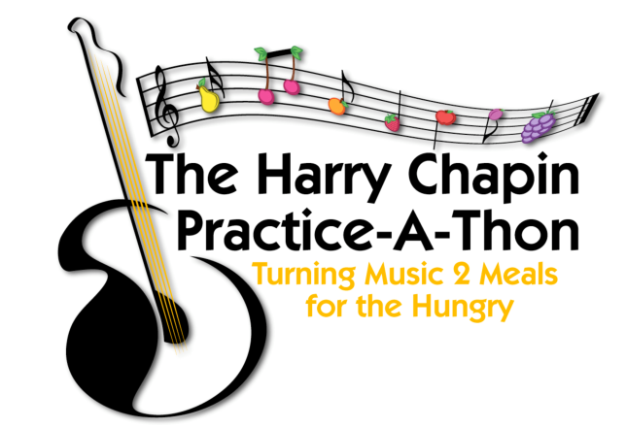
Harry Chapin World Central Kitchen
Practice-A-Thon

Dear Parents,

During April, music students are invited to participate in the Harry Chapin World Central Kitchen Practice-A-Thon, with all proceeds going to the World Central Kitchen (WCK) and their efforts to help families affected by the crisis in Ukraine. Learn more about the good work done by the WCK at their website Wck.org.

Our world needs the lessons that music teaches: how to work together in harmony and peace. And how by working together we can do so much and help so many. We encourage music students to get a sponsor for each minute they practice in April and then practice, practice, practice. The more each musician practices, the more we can help WCK.

The Practice-A-Thon is a beautiful way to strengthen students’ practice habits while encouraging empathy and empowering them to make a difference.

Students who participate in the Practice-a-Thon will need to document their daily practice and list their sponsors in the Participation Packet attached to this letter. The packet can be printed and filled out by hand or on a computer or tablet when downloaded, saved, and then opened with Adobe Reader (a free download).

Sponsors will pledge an amount of their choice per minute the student practices during the month. After the practice-a-thon, students will send a copy of the Sponsor Donation Request Form (at the end of their packet) to their sponsors.

Each sponsor will send their donations directly to the WCK at the following link.
https://donate.wck.org/fundraiser/3776312

Donors should not send money to the school.

Your child will then bring in or email a copy of the completed PRACTICE RECORD to their music teachers, who can celebrate their contribution and practicing 🎉🎉🎉.

You can get more information on the Practice-A- Thon website at hcpracticeathon.com and on the practice-a-thon Facebook page at facebook.com/Practiceathon. Contact me below if you have any questions, and thank you for your participation!

Sincerely,

__________________________________ _______________________________________ _________________________________
Music Teacher School Email

“Alone we can do so little.
Together we can do so much!”
Helen Keller

