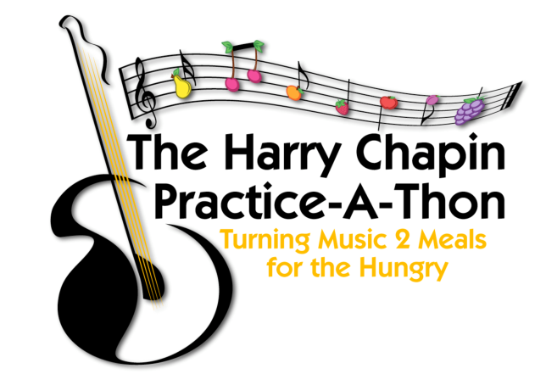

Harry Chapin Practice-A-Thon

Dear Parents,

During this upcoming month, music students across New York State are invited to participate in the Harry Chapin Practice-A-Thon, with all proceeds going to local food banks. Now, more than ever, our food banks need our support. The Practice-A-Thon is a beautiful way to strengthen students’ practice habits while encouraging empathy and empowering them to make a difference in their community.

Students who participate in the Practice-a-Thon will need to document their daily practice and list their sponsors in the Participation Packet attached to this letter. The packet can be printed and filled out by hand or on a computer or tablet when opened with Adobe Reader (a free download). Download and save the packet, then open it with Adobe Reader.

Sponsors will pledge an amount of their choice per minute the student practices during the month. After the practice-a-thon, students will send a copy of the Sponsor Donation Request Form (at the end of their packet) to their sponsors.

Each sponsor will be asked to send their donations directly to your local food bank. Donors should not send money to the school.

Your child will then bring in or email a copy of the completed PRACTICE RECORD to their music teachers, who can celebrate their contribution and practicing 🎉🎉🎉.

You can get more information on the Practice-A- Thon website at hcpracticeathon.com and on the practice-a-thon Facebook page at facebook.com/Practiceathon. Contact me below if you have any questions, and thank you for your participation!

Sincerely,

__________________________________ _______________________________________ _________________________________
Music Teacher School Email

“Alone we can do so little.
Together we can do so much!”
Helen Keller

