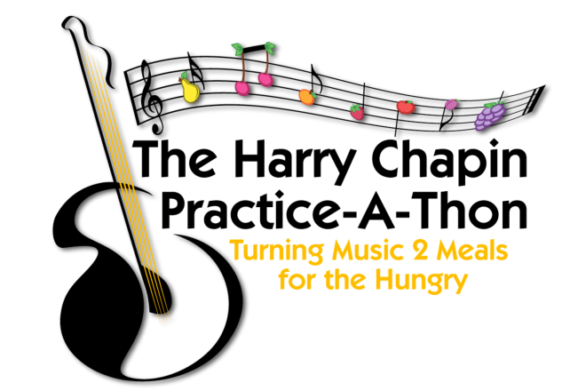***April 2021***

***Harry Chapin Practice-A-Thon Teacher Letter***

Dear Music Teachers,

This April, music students across New York State are invited to participate in the new virtual Harry Chapin Practice-A-Thon, with all proceeds going to local food banks. Now, more than ever, our food banks need our support.

The Practice-a-Thon is a beautiful way to strengthen students’ practice habits while encouraging empathy and empowering them to make a difference in their community. **Teachers will not need to pass out paper packets or collect any money.**

Find the fillable **Participation Packet** for your local food bank on our website, [HCPracticeathon.com](http://hcpracticeathon.com/). The new virtual packet can be filled in on a computer when opened with [Adobe Reader](https://get.adobe.com/reader/) (a free download). This version could be fun for the students as it calculates how much money they are raising with each minute they practice! Or the packet can be printed out and filled in by hand.

**Music teachers who participate will need to do the following:**

1. Fill in the **Parent letter** below with your name and school. Personalize the letter and send it to your parents along with the **Practice-a-thon Packet** for your local food bank.
2. Ask your students to collect sponsors to pledge an amount for each minute they practice. You may want to encourage them to try to practice every day. Tiny donations and tiny amounts of daily practice are all welcome!
3. In May, have the students send a copy of the **Sponsor Donation Request Form** (in their packet) to their sponsors. Sponsors can donate through a direct link or mail the donations to the address provided.
4. Then, ask your students to email a copy of the **Daily Practice Record**

back to you so you can keep track of the contributions and practice.

******Use your creativity to help generate excitement about the project. You can make the project fun with posters, competitions, or small rewards. Visit our website at [hcpracticeathon.com](http://hcpracticeathon.com/) to learn more, download the official **Thank You Certificate** and get ideas on how to get started. Please reach out with any questions, and thank you for helping to make a difference!

“Alone we can do so little;

together we can do so much!”  
Helen Keller

Thank you!

Peggy Rakas, Program Coordinator, “The Harry Chapin Practice-A-Thon”

[harrychapinpractice@gmail.com](mailto:harrychapinpractice@gmail.com) [hcpracticeathon.com](http://www.hcpracticeathon.com/)

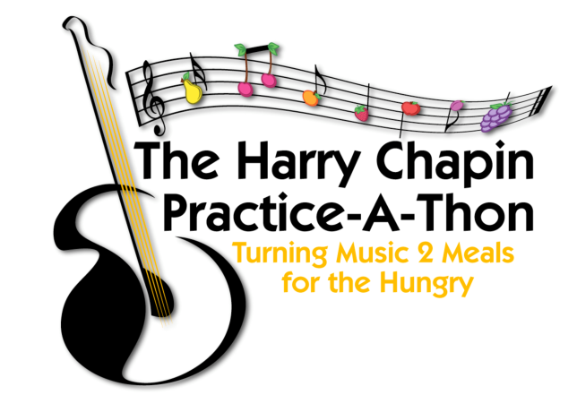**April 2021**

**Harry Chapin Practice-A-Thon**

Dear Parents,

This April, music students across New York State are invited to participate in the Harry Chapin Practice-A-Thon, with all proceeds going to local food banks. Now, more than ever, our food banks need our support. The Practice-A-Thon is a beautiful way to strengthen students’ practice habits while encouraging empathy and empowering them to make a difference in their community.

Students who participate in the **Practice-a-Thon** will need to document their daily practice and list their sponsors in the **Participation Packet**.

The packet can be printed out and filled in by hand or filled in on a computer when opened with [Adobe Reader](https://get.adobe.com/reader/) (a free download). This version could be fun for the students as it calculates how much money they are raising with each minute they practice!

Sponsors will pledge an amount of their choice per minute the student practices during the month. In May, students will send a copy of the Sponsor Donation Request Form (at the end of their packet) to their sponsors.

**Students will not need to collect any money.** Sponsors will make their donations either online or by sending a check directly to the food bank. The online link and address is listed in the Practice-a-thon Packet.

In May, your child should email me a copy of the completed **Daily Practice Record** so I can keep track of our schools minutes practiced and donations raised.  
  
You can get more information on the Practice-A- Thon website at [hcpracticeathon.com](http://hcpracticeathon.com/) and on the practice-a-thon facebook page at [facebook.com/Practiceathon](http://facebook.com/Practiceathon). Contact me below if you have any questions and thank you for your participation!

Sincerely,

__________________________________ _______________________________________ _________________________________

*Music Teacher School Email*

“Alone we can do so little;

together we can do so much!”  
Helen Keller